SIH 25162 - IC Verification Algorithm

Automated Optical Inspection for Counterfeit IC Detection
ALGORITHM OVERVIEW
Our system uses a hybrid two-algorithm approach to verify IC authenticity:
- Algorithm A: RegEx-Based Verification (Direct Pattern Matching)
- Algorithm B: Aho-Corasick-Based Verification (Intelligent Auto-Detection)
Both algorithms use a 3-stage pipeline:
- Stage 1: IC Detection (YOLOv8)
- Stage 2: Text Extraction (Multi-Pass Tesseract OCR)
- Stage 3: Pattern Verification (RegEx/Aho-Corasick)
STAGE 1: IC DETECTION (YOLO)
Input:
- Raw image from camera/upload (RGB, any resolution)
Process:
1. Load YOLOv8 trained model (custom-trained on IC datasets)
2. Run object detection on image
3. Extract bounding boxes of detected IC components
4. Apply padding (10-15px) around detected regions
5. Crop IC marking areas for OCR
Output:
- Cropped IC marking images (numpy arrays)
- Bounding box coordinates
- Detection confidence scores
Technical Details:
- Model: YOLOv8n (custom fine-tuned)
- Confidence Threshold: 0.25
- IOU Threshold: 0.45
- Device: CPU/CUDA (auto-detected)
Stage 2 : Text Extraction and Multi-pass OCR

Input:
- Cropped IC marking image (from Stage 1)
Process:
Step 2.1: Image Preprocessing
1. Convert BGR → Grayscale
2. Apply bilateral filter (noise reduction while preserving edges)
3. Normalize intensity (0-255 range)
4. Apply adaptive thresholding (binary image)
Step 2.2: Multi-Pass OCR Execution
Pass 1: Full Alphanumeric
Purpose: Extract part codes and lot codes
Whitelist: A-Z, 0-9
PSM Mode: 6 (uniform text block)
Example Output: "STM32F030C8T6 2347 A3B5C"
Pass 2: Numeric Only
Purpose: Extract date codes (prevents letter misreads like "O" → "0")
Whitelist: 0-9
PSM Mode: 6
Example Output: "2347"
Pass 3: Alpha Only
Purpose: Extract logo hints and OEM names
Whitelist: A-Z
PSM Mode: 6
Example Output: "STMI"

Output: JSON
{
"full_alphanumeric": {"text": "STM32F030C8T6 2347 A3B5C", "confidence": 0.87},
"numeric_only": {"text": "2347", "confidence": 0.92},
"alpha_only": {"text": "STMI", "confidence": 0.81}
}

Technical Details:
- OCR Engine: Tesseract 4. x (OEM 3 - Default LSTM)
- Preprocessing: Bilateral Filter + Adaptive Thresholding
- Confidence Calculation: Mean of valid word confidences (normalized 0-1)

STAGE 3: PATTERN VERIFICATION

ALGORITHM A: RegEx-Based Verification (Direct Mode)
Use Case: When operator knows which IC is being scanned
Input: JSON
{
"ocr_results": {
"full_alphanumeric": {"text": "STM32F030C8T6 2347 A3B5C", "confidence": 0.87},
"numeric_only": {"text": "2347", "confidence": 0.92}
},
"user_selected_part_id": "stm32f030c8t6"
}
Process:
Step 3A. 1: Load KB Entry
1. Load Knowledge Base entry for "stm32f030c8t6"
2. Extract OEM-defined regex patterns:
- part_code: "\\bSTM32F030C8T6\\b"
- date_code: "\\b[0-9]{2}[0-5][0-9]\\b"
- lot_code: "\\b[0-9A-Z]{3,6}\\b"
3. Compile patterns into regex objects
Step 3A.2: Field Extraction
Apply regex patterns on OCR text:

Pattern 1: part_code regex on full_alphanumeric. text
→ Extract: "STM32F030C8T6"
→ Match: ✅ TRUE

Pattern 2: date_code regex on numeric_only.text
→ Extract: "2347"
→ Match: ✅ TRUE
→ Validate: Year=2023, Week=47 (valid, not future)

Pattern 3: lot_code regex on full_alphanumeric.text
→ Extract: "A3B5C"
→ Match: ✅ TRUE

Logo Hint Check (optional):
→ Search "STMI" in alpha_only.text
→ Match: ✅ TRUE (bonus +0.05)

Step 3A.3: Scoring & Verdict Calculation
Match Count: 3/3 ✅
OCR Confidence: 0.87
Logo Bonus: +0.05
Date Validation: PASS (not future date)

Base Score Calculation:
- 3 matches → 0.90 base confidence
- OCR conf (0.87) → no penalty
- Logo found → +0.05
- Final Score: 0.95

Verdict Threshold Logic:
- 3/3 matches + score ≥ 0.85 → GENUINE
- 2/3 matches + score ≥ 0.50 → UNCERTAIN
- 0-1/3 matches → FAKE

Final Verdict: GENUINE (0.95 confidence)

Output:
{
"verdict": "GENUINE",
"confidence_score": 0.95,
"algorithm_used": "regex",
"matches": {
"part_code_match": true,
"date_code_match": true,
"lot_code_match": true,
"logo_hint_match": true
},
"extracted_fields": {
"part_code": "STM32F030C8T6",
"date_code": "2347",
"lot_code": "A3B5C",
"date_validation": {
"valid": true,
"year": 2023,
"week": 47,
"flags": []
}
},
"oem_info": {
"oem": "STMicroelectronics",
"part_number": "STM32F030C8T6",
"package": "LQFP-48 / QFN-48"
}
}

ALGORITHM B: Aho-Corasick-Based Verification (Auto-Detection Mode)
Use Case: Fully automated - system identifies which IC is present

Input:
{
"ocr_results": {
"full_alphanumeric": {"text": "STM32F030C8T6 2347 A3B5C", "confidence": 0.87},
"numeric_only": {"text": "2347", "confidence": 0.92},
"alpha_only": {"text": "STMI", "confidence": 0.81}
},
"user_selected_part_id": null
}

Process:
Step 3B.1: Token Indexing (Pre-computed at startup)
Build Aho-Corasick automaton from KB:

For each KB entry:
1. Extract tokens from part_number:
- "STM32F030C8T6" → ["STM32F030C8T6"]
- "74HC14 / 74HCT14" → ["74HC14", "74HCT14"]

2. Extract alternatives from part_code pattern:
- "\\bSTM32F030C8T6\\b" → ["STM32F030C8T6"]
- "\\b(74HC14|74HCT14)\\b" → ["74HC14", "74HCT14"]

3. Include logo_hint:
- "STMI", "TEXA", "WINB", etc.

4. Add to automaton:
- Token "STM32F030C8T6" → maps to part_id "stm32f030c8t6"
- Token "STMI" → maps to part_id "stm32f030c8t6"

Total tokens indexed: ~50-100 (for 16 KB entries)

Step 3B.2: Candidate Detection
Run Aho-Corasick string matching on OCR text:

Input Text: "STM32F030C8T6 2347 A3B5C STMI"

Automaton finds:
- Token "STM32F030C8T6" at position 0
→ Candidate: "stm32f030c8t6"
- Token "STMI" at position 20
→ Candidate: "stm32f030c8t6"

Candidate Set: {"stm32f030c8t6"} ✅ Single candidate!

Step 3B.3: Candidate Scoring
For each candidate, apply RegEx verification (same as Algorithm A):

Candidate: "stm32f030c8t6"
- part_code match: ✅
- date_code match: ✅
- lot_code match: ✅
- Score: 3/3 → Confidence 0.95

(If multiple candidates exist, rank by score and return top match)

Step 3B.4: Ambiguity Handling
If multiple candidates have similar scores:
- Candidate A: "stm32f030c8t6" → Score 3/3 (0.95)
- Candidate B: "stm32f030c6t6" → Score 2/3 (0.65)

Action:
- If score difference ≥ 0.20 → Return best candidate
- If score difference < 0.20 → Verdict = "MULTIPLE_CANDIDATES"
→ Flag for admin review

Output (Single Candidate):
{
"verdict": "GENUINE",
"confidence_score": 0.95,
"algorithm_used": "aho_corasick",
"detected_part_id": "stm32f030c8t6",
"candidate_parts": ["stm32f030c8t6"],
"matches": {
"part_code_match": true,
"date_code_match": true,
"lot_code_match": true
},
"extracted_fields": { /* same as Algorithm A */ },
"oem_info": { /* same as Algorithm A */ }
}

Output (Multiple Candidates - Ambiguous):
{
"verdict": "MULTIPLE_CANDIDATES",
"confidence_score": 0.0,
"requires_admin_review": true,
"algorithm_used": "aho_corasick",
"all_candidates": [
{
"part_id": "stm32f030c8t6",
"oem": "STMicroelectronics",
"match_score": 3,
"confidence": 0. 87
},
{
"part_id": "stm32f030c6t6",
"oem": "STMicroelectronics",
"match_score": 2,
"confidence": 0.65
}
]
}

VERDICT DETERMINATION LOGIC
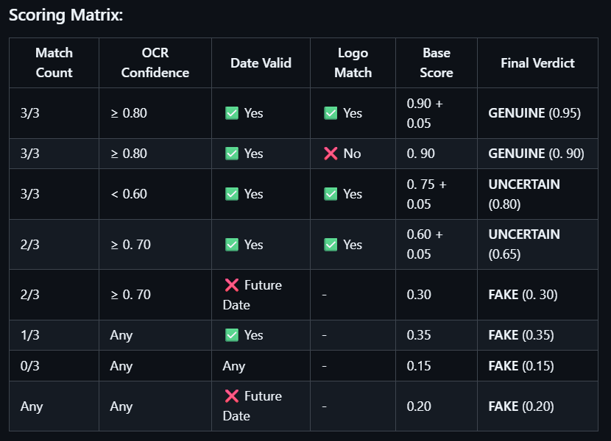

Special Cases:
- Future Date Detection:
  - If date_code year/week is in the future → Auto-FAKE
  - Confidence capped at 0.30 maximum
- Multiple Candidates (Aho algorithm only):
  - If 2+ candidates with score difference < 0.20 → MULTIPLE_CANDIDATES
  - Requires admin review
- Low OCR Confidence:
  - If average OCR confidence < 0.50 → Reduce final score by 0.15
  - Flags as "poor image quality"

TECHNICAL SPECIFICATIONS

Performance Metrics:
- Detection Time: ~150-300ms per image (YOLO)
- OCR Time: ~200-400ms (3 passes)
- Verification Time: ~5-10ms (RegEx) / ~10-20ms (Aho-Corasick)
- Total Pipeline: <1 second per IC
Accuracy Benchmarks (Target for SIH):
- True Positive Rate: ≥ 95% (genuine ICs correctly identified)
- True Negative Rate: ≥ 90% (fake ICs correctly detected)
- False Positive Rate: ≤ 5% (fake ICs marked genuine)
- False Negative Rate: ≤ 10% (genuine ICs marked fake)
Scalability:
- Concurrent Processing: Multi-threading via run_in_executor
- Batch Processing: Supports 10-100 images per batch
- Database Logging: Async MongoDB writes (non-blocking)

ALGORITHM ADVANTAGES (For Judges)

1. Dual-Algorithm Robustness
- Combines deterministic (RegEx) and probabilistic (Aho-Corasick) approaches
- Operator can choose based on use case (speed vs. automation)
2. Multi-Pass OCR Accuracy
- Field-specific character whitelists reduce OCR errors
- Date codes extracted with 0-9 only (prevents "O"→"0" mistakes)
3. Future-Proof Date Validation
- Automatic detection of impossible dates (clear fake indicator)
- Validates manufacturing week (1-53 range)
4. Intelligent Auto-Detection
- Aho-Corasick enables substring matching in O(n) time
- No manual part selection needed in automated mode
5. Audit Trail & Traceability
- All verifications logged to MongoDB
- Admin review queue for ambiguous cases

